Criteria Pollutants Annual Report Business Rules (CPARBR)

Overview
The purpose of this document is to outline the rules for analyzing and reporting air quality monitoring data for annual reports. There are several complexities and considerations to be made when analyzing AQM data and this document will guide analysts in what those complexities and considerations are.

Hierarchy of PM2.5 Monitors
The air quality monitoring network has several different monitor types for PM2.5. This is based on federal requirements for monitoring, increasing the spatial size of the network with low-cost sensors, and capturing historical trends in PM2.5 levels.
There are several AQM sites that have collocated monitors. When this is the case, there is a hierarchy to follow when deciding what monitor’s data we want to use for the annual reports. If that monitor type is not available, use the next level in the hierarchy. Table 1 below summarizes the monitor types and the hierarchy to follow.

Monitor | Data Quality | Hierarchy Level | Duration | Data Location
BAM 1022 | Regulatory | 1st | Continuous | Envista/AQS
Nephelometer | Informational | 2nd | Continuous | Envista/AQS
SensOR | Informational | 3rd | Continuous | Envista
Wilbur FRM | Regulatory | 1^{st*} | 24-hr Samples | Element/AQS
*Wilbur FRM samples can be used to fill in gaps when BAM 1022 data is not available.

Wildfire Data for PM2.5
Wildfire affect air quality is becoming an increasing concern for Oregon communities. Therefore, the analyst handling wildfire affected data must handle this data with care. In short, the analyst must report annual datasets with and without wildfire affected data. In this way, we can show communities the levels of PM2.5 levels they were exposed to but also show if we are in compliance with the NAAQS with wildfire affected data removed.
Wildfire season is from June 1st to October 25th (excluding July 4th). The threshold for daily average PM2.5 levels considered to be affected by wildfire smoke during this period is 25 ug/m3.
The analyst will need to calculate design values with and without wildfire data. The daily PM_{2.5} design value standard is an annual 98th percentile of daily averaged PM_{2.5} concentrations, averaged over three years, and set to a level of 35 µg/m³. The annual PM_{2.5} design value standard is an annual average of quarterly averages of daily averaged PM_{2.5} concentrations, averaged over three years, and set to a level of 12.0 µg/m³.
*From the 2024 annual report
To be classified as wildfire data, data must be recorded during wildfire season ( June 1 through October 25) and have a daily averaged PM_{2.5} concentration greater than 25 µg/m³. By removing data impacted by wildfire, design values show the significant impacts of wildfire smoke, reflect a value more representative of the design value time period and reveal the impact of local air quality improvement programs. The EPA may formally exclude data impacted by wildfire from design value calculations by designating wildfires as exceptional events. More information about exceptional events can be found on EPA’s website (https://www.epa.gov/air-quality-analysis/treatment-air-quality-monitoring-data-influenced-exceptional-events).

Below are examples of tables and charts that report data with and without wildfire data.
Monitoring Area | Three-Year Average of 98th Percentiles (µg/m³) |  |  | Three-Year Average of Annual Averages (µg/m³)
Monitoring Area | Including Wildfire Smoke Impacted Data | Excluding Wildfire Smoke Impacted Data | % of Std with no WF smoke | Including Wildfire Smoke Impacted Data | Excluding Wildfire Smoke Impacted Data | % of Std with no WF smoke
From Regulatory Monitors
Burns | 55 | 26 | 73% | 11.4 | 8.7 | 97%
Cottage Grove | 29 | 20 | 56% | 7.1 | 6.4 | 71%
Eugene Metro | 28 | 28 | 79% | 7.7 | 7.7 | 86%
Grants Pass | 36 | 22 | 62% | 9.0 | 6.7 | 74%
Klamath Falls | 34 | 26 | 73% | 8.7 | 7.4 | 82%
Lakeview | 31 | 28 | 79% | 7.5 | 6.8 | 76%
Medford | 45 | 23 | 65% | 10.0 | 8.8 | 98%
Oakridge | 111 | 24 | 68% | 13.9 | 7.1 | 79%
Portland Metro | 24 | 19 | 54% | 6.2 | 6.0 | 67%
Prineville | 35 | 20 | 56% | 7.3 | 6.0 | 67%
Salem Metro | 24 | 24 | 68% | 6.5 | 6.5 | 72%
Estimates from Informational Monitors
Albany | 20 | 20 | 56% | 5.5 | 5.5 | 61%
Ashland | 45 | 17 | 48% | 7.0 | 4.9 | 54%
Baker City | 26 | 19 | 54% | 7.2 | 6.5 | 72%
Bend | 49 | 21 | 59% | 9.4 | 5.9 | 66%
Cave Junction | 73 | 24 | 68% | 11.5 | 8.0 | 89%
Corvallis | 14 | 14 | 39% | 4.4 | 4.4 | 49%
Enterprise | 26 | 19 | 54% | 6.5 | 5.9 | 66%
John Day | 47 | 25 | 70% | 11.0 | 9.3 | 103%
La Grande | 22 | 22 | 62% | 6.3 | 6.3 | 70%
Pendleton | 21 | 21 | 59% | 6.2 | 6.2 | 69%
Roseburg | 32 | 20 | 56% | 9.7 | 7.8 | 87%
Sisters | 58 | 20 | 56% | 7.8 | 5.2 | 58%
Sweet Home | 19 | 19 | 54% | 5.9 | 5.9 | 66%
The Dalles | 21 | 21 | 59% | 5.9 | 5.9 | 66%
2022-2024 PM_{2.5} Design Values

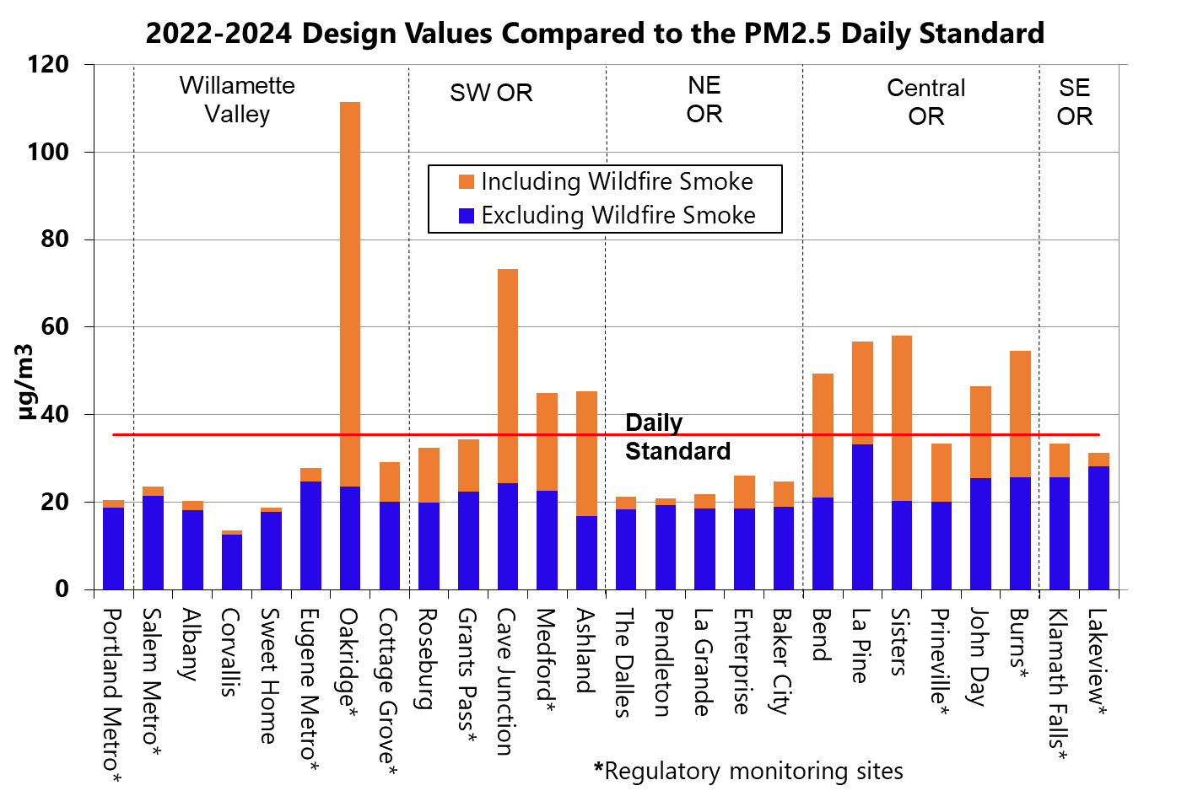

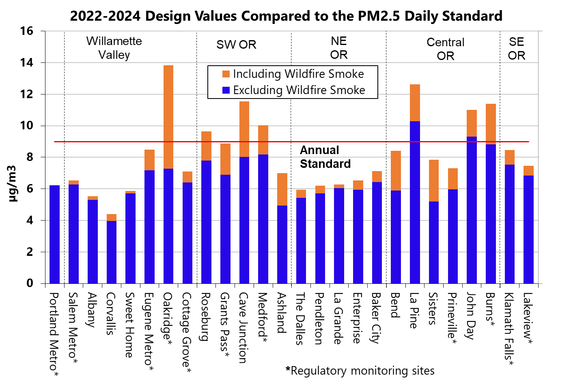

Clustered monitors for cities and regions
There are cities and regions in Oregon that have multiple monitors in proximity. To report data from these monitors, several considerations must be made. First, let’s look at what the clustered cities or regions are for the network in 2025. Note, these sites and monitors are likely to change slightly from year to year.

When reporting data from clustered monitors we take the highest daily average from the monitors in the group.
PM2.5
Portland Metro
Site Name | Site Address | Monitor Type | EPA Site ID
Portland SE Lafayette | 5822 SE Lafayette | BAM 1022 | 410510080
Portland SE Lafayette | 5822 SE Lafayette | Nephelometer | 410510080
Portland SE Lafayette | 5822 SE Lafayette | SensOR | 410510080
Tualatin Bradbury Court (TBC) | 6745 Bradbury Court | BAM 1022
Tualatin Bradbury Court (TBC) | 6745 Bradbury Court | Nephelometer
Beaverton Highland Park School (BHP) | 7000 SW Wilson St | Nephelometer
Hillsboro Hare Field | 1149 NE Grant St. | BAM 1022
Hillsboro Hare Field | 1149 NE Grant St. | Nephelometer
Portland Cully Helensview School (PCH) | 8678 NE Sumner St. | Nephelometer
Gresham Centennial HS | 3505 SE 182nd Ave | SensOR
Gladstone Highschool | 18800 Portland Ave | SensOR
Portland Benson HS | 546 NE 12th Ave | SensOR
Portland Humboldt School | 4915 N Gantenbein Ave | SensOR
Portland Lincoln HS | 1600 SW Salmon St | SensOR
Portland Lane Middle School | 7200 SE 60th Ave | SensOR
Portland McDaniel HS | 2735 NE 82nd Ave, Portland 97220 | SensOR
Portland Roosevelt HS | 6941 N Central St | SensOR
DEQ VIP 12th & Main | SE 12th and SE Main | SensOR
Salem Metro
Site Name | Site Address | Monitor Type
Salem State Hospital | 867 Medical Center | BAM 1022
Salem State Hospital | 867 Medical Center | Nephelometer
Salem Chemeketa CC | 4000 Lancaster Dr NE | SensOR
Eugene Metro
Site Name | Site Address | Monitor Type
Eugene Amazon Park | 599 E 29TH | BAM 1022
Eugene Amazon Park | 599 E 29TH | Nephelometer
Eugene Hwy 99 | 530 Hwy 99 North | BAM 1022
Eugene Hwy 99 | 530 Hwy 99 North | Nephelometer
Eugene Wilkes Drive | 943 Wilkes Ave. | Nephelometer
Bend Metro
Bend Pump Station | 35 NW Portland St | BAM 1022
Bend Pump Station | 35 NW Portland St | Nephelometer
Bend Eighth & Emerson | 230 NE 6th St, Bend, OR 97701 | SensOR
Bend Ponderosa Elementary | 3790 NE Purcell Blvd, Bend, OR 97701 | SensOR
Bend Road Dept. | 61150 SE 27th St, Bend OR 97702 | SensOR
Bend Pine Ridge Elementary | 19840 Hollygrape St, Bend, OR 97702 | SensOR
Sun River Elementary | 56900 Enterprise Dr, Sunriver, OR 97707 | SensOR

Ozone
Portland Metro
Site Name | Site Address | Monitor Type | EPA Site ID
Portland SE Lafayette | 5822 SE Lafayette, Portland, OR 97206 | Ozone | 410510080
Sauvie Island | Rt1 Box 4222 SS Beach | Ozone | 410090004
Carus Spangler Road | 13575 Spangler Rd. | Ozone | 410050004
Tualatin – I-5 | 6745 Bradbury Court | Ozone | 410670005
Salem Metro
Site Name | Site Address | Monitor Type | EPA Site ID
Salem State Hospital | 867 Medical Center | Ozone | 410470041
Turner Cascade Jr. High School | 10226 Marion Rd SE | Ozone | 410470004
Eugene Metro
Site Name | Site Address | Monitor Type | EPA Site ID
Eugene Amazon Park | 599 E 29TH | Ozone | 410390060
Saginaw | 80020 North Delight Valley School Rd. | Ozone | 410391007

From the tables you can see that we currently only have PM2.5 and Ozone that have monitors in proximityDue to ozone’s ability to transport,
When reporting data from clustered monitors we take the highest daily average from the monitors in the group.

Valid # of hours in a day for calculations
When calculating daily averages from continuous data, the general rule is to have at least 75% of hourly values available (i.e., 18 out of 24 hours).

